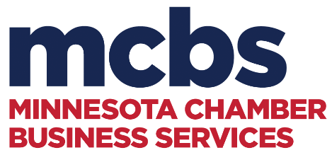
ORGANIZATIONAL BASICS FOR EVERY DMO CHECKLIST
MACVB Education Summit | April 18, 2024

- 990’s
- Annual budget
- Annual business plan
- Articles of Incorporation
- Audit policy
- Banking records, ie. check signing authority, accounts, etc.
- Board of Directors job description
- Board of Directors roster
- Bylaws
- Compensation policy
- Conflict of interest policy
- Contracts, leases, etc.
- Depreciation schedule
- Emergency plan and contact sheet
- Employee handbook
- Employee performance reviews
- Financial management procedures
- Financial statements – balance sheet + profit & loss
- Guiding principles: mission, vision, value statements
- Insurance policies - general liability (umbrella), directors and officers, employee practices, fiduciary, workers’ compensation
- IRS Determination letter
- Meeting minutes of board meetings
- MN Secretary of State annual filing
- Notices required to be posted – labor law posters
- Operating agreements – lodging tax, etc.
- Payroll records and federal deposits
- Record retention policy
- Sales tax filings, quarterly, if applicable
- Six manuals concept
- Social media policy
- Staff job descriptions
- Strategic plan
- Unemployment records
- Whistle blower policy
- Workers’ compensation annual reporting

- Red Book (update annually)

